***Assignment A2(a)***

#Source Code:

--Practical 2:

drop table employee;

create table employee(

emp_id integer,

emp_name varchar(10),

age integer,

dpmt_name varchar(20),

dpmt_id varchar(5),

salary integer,

Experience varchar(10),

AreaofExpertise varchar(50),

email_id varchar(30),

primary key (emp_id,email_id)

);

SELECT * FROM employee;

DROP sequence sequence_Maxx;

--Create a sequence to generate employee id:

CREATE SEQUENCE sequence_Maxx

start with 501

increment by 1

minvalue 501

maxvalue 510

Nocache

cycle;

INSERT INTO employee VALUES(sequence_Maxx.nextval,'Mayuresh',25,'Computer','e101',50000,'3yrs','Data Science','mayuresh12@gmail.com');

INSERT INTO employee VALUES(sequence_Maxx.nextval,'Mitesh',34,'Computer','e102',55000,'10yrs','Cyber Security','mitesh25@yahoo.com');

INSERT INTO employee VALUES(sequence_Maxx.nextval,'litesh',33,'Electrical','e103',77000,'9yrs','Big Data','litesh29@yahoo.com');

INSERT INTO employee VALUES(sequence_Maxx.nextval,'Reena',22,'Chemical','e104',100000,'1yr','Thermodynamics','reena12@yahoo.com');

INSERT INTO employee VALUES(sequence_Maxx.nextval,'Rohan',36,'Mechanical','e105',45000,'10yrs','Design','rohan41@gmail.com');

INSERT INTO employee VALUES(sequence_Maxx.nextval,'Rekha',32,'Civil','e106',56000,'8yrs','Brigdes','rekha23@hotmail.com');

INSERT INTO employee VALUES(sequence_Maxx.nextval,'Harshali',34,'AIDS','e107',120000,'7yrs','Artificial Intelligence','harshali05@gmail.com');

INSERT INTO employee VALUES(sequence_Maxx.nextval,'Rehan',22,'EnTC','e108',67000,'2yrs','Image Processing','rehan52@hotmail.com');

INSERT INTO employee VALUES(sequence_Maxx.nextval,'Shawn',24,'Mechanical','e109',69000,'2yrs','Production','shawnlewy67@hotmail.com');

INSERT INTO employee VALUES(sequence_Maxx.nextval,'Jaackie',28,'Chemical','e110',90000,'5yrs','Plastic','maxx6969@yahoo.com');

--Create a view that will display all details except Salary and Area of Expertise:

CREATE VIEW employee_maxx ASSELECT emp_id,emp_name,age,dpmt_name,dpmt_id,experience,email_id FROM employee;

SELECT * FROM employee_maxx;

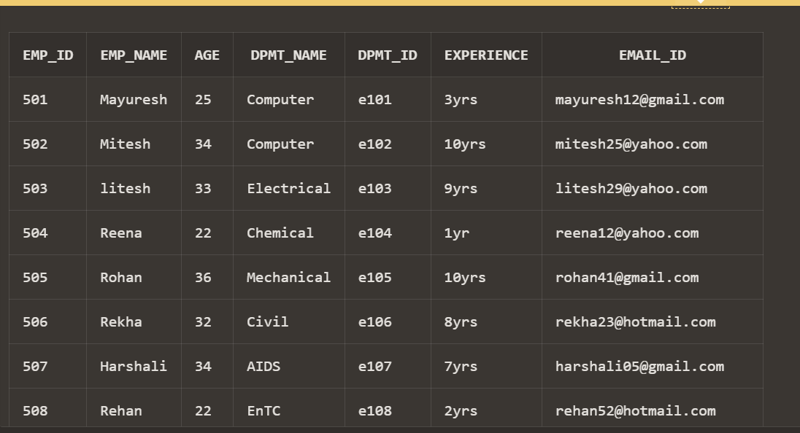

--Create an INDEX for column ID:

CREATE INDEX index_id ON employee(emp_id);

SELECT * FROM employee;

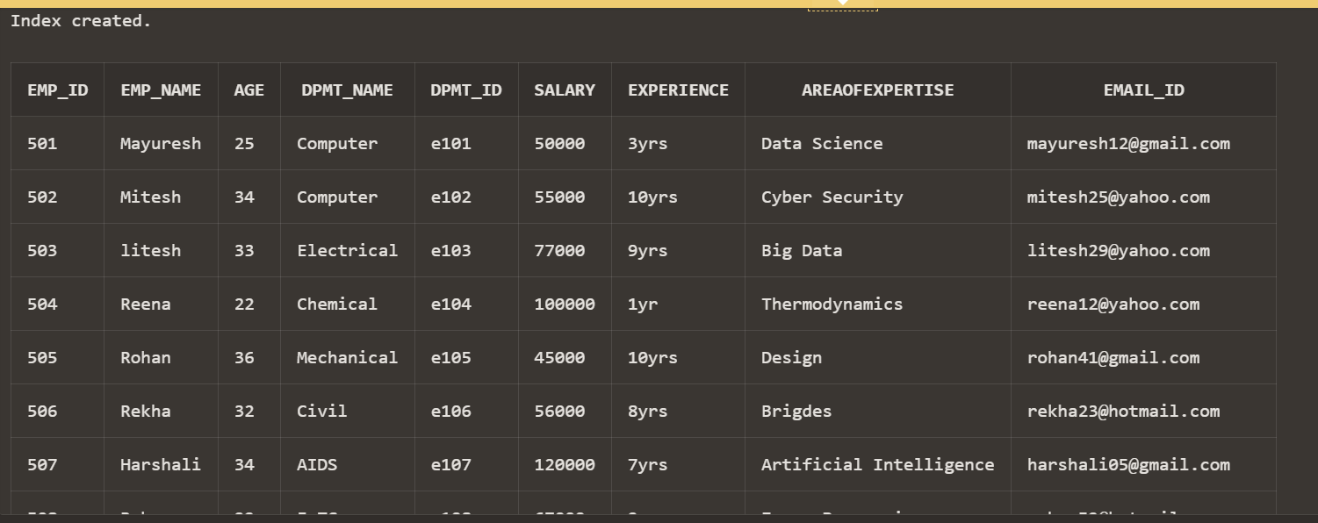

--Create Synonym for generated table as 'EMP' and demonstrate its use:

DROP SYNONYM emp;

CREATE SYNONYM emp FOR employee;

SELECT * FROM employee;

